Cascade reactions within polymersome clusters: from model to application

Compartimentalization is a fundamental aspect of biology. To study how the distance between compartments influences the communication and the reaction efficiency, we need to control the distance between them and polymersomes. By conjugating complementary DNA strands on them, polymersomes from binary clusters with inter-vesicle distance tuneable by simply varying the length of the DNA bridge. In addition, the DNA also interacts with the membrane proteins mammalian cells, opening the possibility to selectively act upon the membrane-exterior interface.
This project will consist of two main phases: in the first phase, the enzymatic cascade mediated by superoxide dismutase (SOD) and lactoperoxidase (LPO), detoxifying both the dangerous ROS superoxide and hydrogen peroxide, will be characterized at different DNA lengths and we will derive a model of the dependence cluster diffusion of the reaction efficiency. In the second phase, we will study the interaction of these catalytically active clusters with different cell lines and verify their ability to help the cells survive oxidative stress, a major cause of cell damage.
Several different physicochemical techniques will be used to study the nanoscale assemblies composed of polymers, enzymes and DNA, coupled to the biochemical analysis of enzymatic activity and basic toxicology studies on cell cultures, making this a largely interdisciplinary project that will provide with a broad overview on nanobiotechnology research.
If interested please contact Andrea Belluati (andrea.belluati@unibas.ch) with your CV and a tentative starting date. 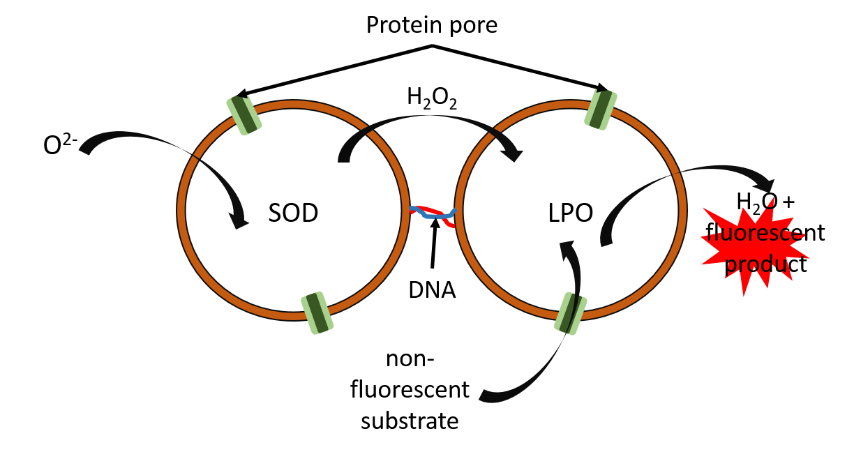

[1] Tanner, P., et al., Enzymatic cascade reactions inside polymeric nanocontainers: a means to combat oxidative stress. Chemistry, 2011. 17(16): p. 4552-60.
[2 Liu, J., et al., DNA-Mediated Self-Organization of Polymeric Nanocompartments Leads to Interconnected Artificial Organelles Nano letters, 2016. 16(11): p. 7128–7136.
[3] Palivan, C.G., et al., Protein-polymer nanoreactors for medical applications. Chem Soc Rev, 2012. 41(7): p. 2800-23.

